Thank you for partnering with The University of Florida College of Pharmacy for your Continuing Pharmacy Education needs. The University of Florida College of Pharmacy is accredited by the Accreditation Council for Pharmacy Education as a provider of continuing pharmacy education and as such is responsible for upholding the Standards set forth by ACPE. This document is meant to serve as a FAQ tool for you to assist in your requests to have programs accredited for pharmacist and/or technician continuing education credit. Should you have questions that are not addressed in this document, please do not hesitate to reach out to our office, contact information is below.

- What is the first step in applying for pharmacist and/or technician CE accreditation for a program?
  - Prior to submitting an application, you are encouraged to contact the Office of Continuing Pharmacy Education (Office of CPE) to discuss your program and needs to ensure alignment with the mission and goals of the office.
  - You must submit an application for CPE Program application. This can be found on our website at: http://cpe.pharmacy.ufl.edu under the partnering with us tab or can be requested by contacting our office at cesupport@ahc.ufl.edu
  - All efforts should be made to ensure that The University of Florida College of Pharmacy Office of Continuing Pharmacy Education is involved in all stages of development of the activity, including planning, development, promotion, delivery, evaluation, and revision. The Office of Continuing Pharmacy Education will not be able to accredit programs that are fully developed, ready for launch, and simply needing an accreditation stamp.
  - Before submitting your application, please make sure all of the following are included in your application package.
    - Signed application
    - Needs assessment
    - Objectives
    - Planning process documentation
    - Proposed activity agenda
    - Copy of activity announcement/brochure
    - Disclosure forms for anyone in control of content (speakers, planning committee)
    - CV for all speakers
    - Test questions for home study programs
  - Completed applications should be submitted online.
- How soon must the application be submitted?
  - All applications and accompanying documents must be received a minimum of 30 days PRIOR to the date of the live activity or desired release date for home study activities.
  - However, if your program requires Florida Board Approval (Medication Errors, HIV, any course for consultant pharmacist renewal), the completed application and accompanying documents must be received a minimum of 60 days PRIOR to the date of the live activity or desired release date for home study activities.
- How will I know what services the Office of Continuing Pharmacy Education will provide and what I am responsible for?
  - Each partner of the Office of Continuing Pharmacy Education must have an up to date letter of agreement (LOA) signed by UF COP and your office designee. This LOA must be fully executed prior to review of content. One LOA per institution, signed annually may meet this requirement, depending on the details.
- What is the difference between knowledge, application, and practice based activities?
  - Per ACPE, CPE Policies and Procedures Manual, Section V, Policy 2 states:
    - Knowledge based CPE activities are primarily constructed to transmit knowledge. The facts must be based on evidence as accepted in the literature by health care professionals. The minimum amount of credit for these activities is 15 minutes or 0.25 contact hours. Most CE activities fall into this category.
    - Application based CPE activities are primary constructed to apply the information learned in the time frame allotted. The information must be based on evidence as accepted in the literature by health care professionals. The minimum amount of credit for these activities is 60 minutes or one contact hour.
    - Practice based activities are primarily constructed to instill, expand, or enhance practice competencies through the systematic achievement of specified knowledge, skills, attitudes, and performance behaviors. The information must be based on evidence as accepted in the literature by health care professionals. The formats of these CPE activities should include a didactic component and a practice experience component. The minimum amount of credit for these activities is 15 contact hours.
- How do I write a needs assessment for my program?
  - A needs assessment is utilized to document the following: professional practice gap (current knowledge/practice and how it differs from the desired knowledge/practice) and how the program will fill these needs and gaps, including desired outcomes.
  - All needs assessments must include references to the current health care professional literature. Include citations for how the gap was identified and what references will be used to construct the program, filling the gap.
  - As needs assessments are based on professional knowledge and practice based responsibilities, the needs assessments must be specific to your audience. This means that if you are seeking pharmacist and technician credit, the needs assessments will be different.
  - An example of a well-constructed needs assessment is provided in appendix 1. You do not have to use this format. If you prefer to include a paragraph describing the needs assessment, that is acceptable.
- What are the requirements for writing learning objectives for the program?
  - Per ACPE, CPE Standards, Standard 4 learning objectives should be specific and measurable with learning following along a continuum of cognitive learning domain.
  - The objectives should be appropriate for the learning audience and applicable to the area of practice and professional responsibilities. This means that if you are seeking pharmacist and technician credit, the learning objectives will be different.
  - When choosing verbs to construct the objectives, please see guidance provided by ACPE in appendix 2.
- What is active learning and do I have to incorporate this into my program?
  - Per ACPE, Standard 7 for Continuing Pharmacy Education all CPE activities should include active participation and involvement of the learner. The methodologies employed should be determined by the type of activity (knowledge, application, practice), the objectives, educational content, and size and composition of audience.
  - In addition, all programs must include an assessment of learning so that the learner may assess their achievement of the learned content. Completion of learning assessment is REQUIRED. For live activities, this is most often done informally through participant discussion. However, home study activities require more formal assessment techniques such as test and quizzes. For both live and home study activities, assessment feedback must be provided (verbal feedback for live discussions or written, graded feedback for home based activities)
  - Examples of active learning activities and assessment types include:
    - Knowledge Based Activities: Learning activities may include lectures with examples, analogies, visual illustrations, and/or examples. Assessment includes questions structured to recall facts.
    - Application Activities: Learning activities may include role play, simulations, demonstrations, practice exercises. Assessment must include case studies structured to address application of the principles learned.
    - Practice Based Activities: Learning activities may include case studies, simulations, and projects. Assessment must include formative and summative assessment that allow the learner to demonstrate that they have achieved the stated objectives.
- What are the required components for the program brochure/advertisement?
  - All program brochures/advertisements must be approved by the CPE Office prior to distribution.
  - You may distribute save the date cards to alert learners of an activity prior to the brochure being approved. However, you may NOT use any language alluding to or indicating that ACPE credit has been applied for.
  - ACPE CPE Policies and Procedures, Section V Policy 4 lists specific elements of CPE activity announcement brochures and advertisements. Please see appendix 3 for the detailed requirements.
  - If you are applying for the Office of Continuing Pharmacy Education to accredit your program, you own the material and therefore copyright belongs to you. Please make sure to notate copyright on your activity brochure.
  - You must provide a link to UF’s privacy policy on your brochure. Please use the following: http://privacy.ufl.edu/privacy-policies-and-procedures/information-privacy-statement/
- What are the requirements for participants to gain CE for attending a live activity?
  - The minimum requirements are that the participant attend the entire session with record of attendance provided and complete a program evaluation. No partial credit can be awarded.
- What are the requirement for participants to gain CE for participating in a home study activity?
  - The minimum requirements are that the participant complete the entire activity, complete a program evaluation, and pass a post-program knowledge assessment. It is recommended that participants score at least 70% on post program assessments.
  - When you submit your application, you will need to submit test questions. These must be different for pharmacists and technicians. A general rule is ~10 questions per 1H home study credit.
- What is the best way to document the planning process of the CPE program?
  - The Office of CPE should be involved in the planning stages CPE program.
  - A planning committee consisting of at least 3 members should be used to identify program need, approval of topic, objectives, and content. The planning committee is responsible for the quality of the program.
  - Record of email correspondence, informal notes and record of phone conversation should be provided to provide evidence of quality control.
- Do I have to use a specific evaluation form?
  - The Office of Continuing Pharmacy Education requests that you use their standard online evaluation form. This form has been reviewed and meets the requirements per ACPE Accreditation Standards for Continuing Pharmacy Education, Standard 11.
- Do I have to provide a disclosure slide even if I don’t have anything to disclose?
  - Yes. All presentations must document disclosures. This must be done at the beginning of any educational activity. An individual must disclose the following:
    - The name of the individual
    - The name of the commercial interest
    - The nature of the relationship
  - If the individual has nothing to disclose, the learner must be informed that no relevant financial relationships exist.
- Do I have to turn in my presentation with the application?
  - The presentation content MUST be reviewed and approved 14 days PRIOR to the live event or release of home study material. It is recommended that you submit the presentation outline at the time you submit your application. Please contact our office to determine how soon in advance the final presentation must be submitted for review and approval.
- Do I have to include references?
  - You are highly encouraged to include references on each slide of your presentation if using ppt. Otherwise a list of references will be acceptable.
- How will I know if my program has been accredited by your office?
  - Once your program is approved you will receive an email from our office indicating approval of submitted material. At the time of approval, you will receive an UAN, unique activity number, which indicates that the program is approved for continuing pharmacy education.
- How does the CPE office report credit? What information do I need to provide your office?
  - The Office of CPE will report to CPE Monitor and/or CE Broker within 60 days of the course completion. The Office of CPE does NOT provide certificates of completion, per ACPE. If participants want record of CE activities they may login to their NABP profile and print their own records.
  - If the Office of CPE is reporting credit on your behalf as stated in the LOA, you must provide all record of attendance within 30 days of activity completion so that we may report credits in a timely fashion.
  - In order for our office to report credit we need the following participant information:
    - Name
    - DOB (MMDD)
    - NABP number
    - FL License number if applicable
    - Email
  - If the Office of CPE is unable to report credit within the 60 day ACPE imposed deadline due to incorrect participant information, there will be NO retroactive reporting.
- How can I contact your office?
  - The Coordinator of CPE, Dominique Easterling, can be reached at 352-273-5169 or deasterling@ufl.edu
  - The Office of CPE Director, Megan Murphy-Menezes, Pharm.D., MSCR, can be reached at 352-273-6275 or you may email at mmenezes@cop.ufl.edu
  - General inquires can be made using the following email: cesupport@ahc.ufl.edu
  - Please check our website for commonly used forms http://cpe.pharmacy.ufl.edu under the partnering with us tab.

Appendix 1: Example of a well-constructed needs assessment
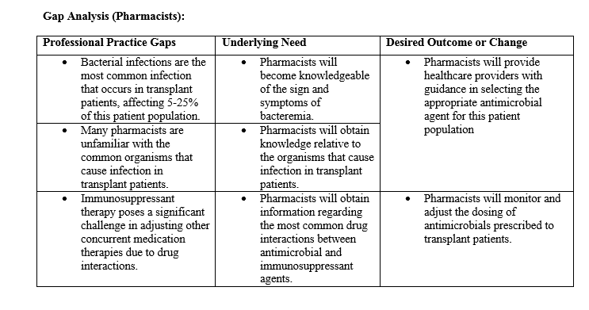
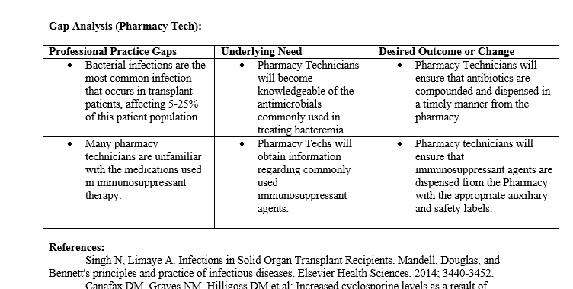

Appendix 2: ACPE Guidance for Learning Objectives
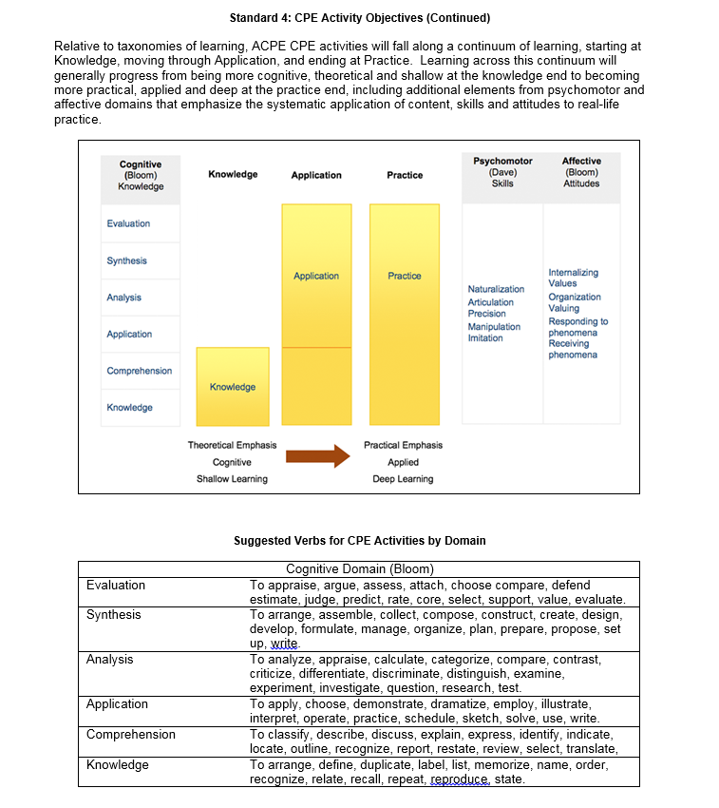

Appendix 3: Program Brochures and Advertisements
